
Syrian private university
Faculty of Engineering

AQARI WEB
مشروع تخرج2
اعداد الطلاب :
محمد محمد راغب عبيد
يوسف محمد الرفاعي

بإشراف المهندس:
ماهر صارم

2026
أهداء

بِقَلْبٍ مُمتَنٍّ، نُهدي هذا النّجاح، الذي لم يكن ليكتملَ لولا توجيهاتُك، إلى التي كانت لنا سنداً منذ البداية
المهندس ماهر صارم

إلى الذي لولاهُ، لما كانت كليّتنا مميّزةً بكادرِها ومِنهاجِها. إلى الذي يَبذل كلّ جُهدِه كي نكون الأميزَ والأفضل
الدكتور مهيب النقري

المستخلص
يهدف هذا المشروع إلى تصميم وتطوير منصة عقارية متكاملة باسم «عقاري» تخدم السوق العقاري في الجمهورية العربية السورية، من خلال توفير بيئة رقمية تجمع المالكين والمستأجرين والمشترين في مكان واحد. اعتمد المشروع على منهجية التطوير الرشيقة (Agile) ضمن إطار Scrum، وبُني باستخدام إطار العمل Django بلغة Python، وقاعدة بيانات SQLite، وتقنيات الويب الحديثة. يدعم النظام المحافظات السورية الأربع عشرة، وتصنيف العقارات حسب النوع والحالة، مع نظام تقييم حسابي، وآلية لعرض العقارات الأكثر مشاهدة وفق بيانات حقيقية، ولوحة إدارة متطورة. أثبتت نتائج الاختبار تحقيق جميع الأهداف بنسبة نجاح 100% ورضى مستخدمين تجاوز 92%.
الكلمات المفتاحية: منصة عقارية، Django، Python، تطوير الويب، السوق السوري، Agile، نمط MVT، قواعد البيانات.

Abstract
This project aims to design and develop an integrated real estate platform named "Aqari" to serve the real estate market in the Syrian Arab Republic. The platform provides a digital environment that brings together property owners, tenants, and buyers in one place. The Syrian real estate market faces numerous challenges, including difficulty accessing reliable information and the absence of modern electronic systems for managing property listings.
The project adopted the Agile development methodology within the Scrum framework. The system was built using the Django framework with Python as the backend, an SQLite database, and modern web technologies (HTML5, CSS3, Bootstrap 5, JavaScript). The system supports all fourteen Syrian governorates, with property categorization by type (apartments, villas, lands, offices) and status (for sale, for rent).
The system includes several intelligent features, most notably an arithmetic rating system for properties based on user opinions, a ranking mechanism for the most-viewed properties based on real data, an advanced multi-criteria search system, favorites management, and an advanced administrative dashboard with a modern design. The interface is fully bilingual with RTL support and a responsive design for all devices.
Test results proved the effectiveness of the system in achieving its objectives, with a property display accuracy of 100%, a response time of less than two seconds in most operations, and a user satisfaction rate exceeding 92% in preliminary tests.
Keywords: Real Estate Platform, Django, Python, Web Development, Syrian Market, Recommendation Systems, Agile, MVT Pattern, Relational Databases.

Table of Contents
SECTION ONE: PROJECT INTRODUCTION
Chapter 1: General Introduction
Chapter 2: Project Development & Management Methodology
SECTION TWO: THEORETICAL STUDY & ANALYSIS
Chapter 3: Literature Review & Previous Studies
Chapter 4: Requirements Modeling & Analysis
SECTION THREE: DESIGN & ARCHITECTURE
Chapter 5: System Architectural Design
SECTION FOUR: IMPLEMENTATION & TESTING
Chapter 6: Implementation Environment & Tools
Chapter 7: Software Implementation
Chapter 8: Testing & Evaluation
SECTION FIVE: RESULTS & RECOMMENDATIONS
Chapter 9: Results & Analysis
Chapter 10: Conclusion & Recommendations
SECTION SIX: APPENDICES & REFERENCES
Appendices
References

List of Tables
Table 2-1: Comparison between Agile and Waterfall
Table 2-2: Project Timeline (Sprints)
Table 2-3: Risk Management Register
Table 4-1: Stakeholder Analysis
Table 4-2: Functional Requirements (25 FR)
Table 4-3: Non-Functional Requirements
Table 4-4: MoSCoW Prioritization
Table 4-5: Use Case Descriptions
Table 4-6: Requirements Traceability Matrix
Table 5-1: Property Table Schema
Table 5-2: Database Constraints
Table 8-1: Test Cases
Table 8-2: Test Results Summary
Table 9-1: Comparison with Existing Systems

List of Figures
Figure 4-1: Use Case Diagram
Figure 4-2: Activity Diagram (Add Property)
Figure 4-3: Sequence Diagram (Rate Property)
Figure 5-1: System Architecture (MVT Pattern)
Figure 5-2: Entity Relationship Diagram (ERD)

List of Abbreviations
Term | Definition
Django | Open-source Python web framework using the MVT pattern
MVT | Model-View-Template architectural pattern used by Django
ORM | Object Relational Mapping technique
CRUD | Create, Read, Update, Delete database operations
RTL | Right-To-Left text direction (for Arabic)
SQLite | Lightweight file-based relational database system
Bootstrap | CSS framework for responsive web interfaces
REST | Representational State Transfer architectural style
UI/UX | User Interface / User Experience
CSRF | Cross-Site Request Forgery (a web attack)
SCM | Software Configuration Management
Agile | Iterative software development methodology
Scrum | A framework within the Agile methodology
MoSCoW | Requirements prioritization (Must, Should, Could, Won't)

SECTION ONE
Project Introduction

Chapter 1
General Introduction

Objective: To introduce the project to the reader, explain its importance, and highlight what is new about it.

1.1 Project Overview and Background
The "Aqari" project falls within the field of management information systems and intelligent web applications, which are vital areas that have witnessed remarkable development in recent years at both global and regional levels. The need for specialized digital platforms in the real estate sector is increasing due to the technological transformation the world is experiencing today.
In the Syrian Arab Republic, particularly after years of economic and social transformations, the real estate sector emerges as one of the most vital sectors in need of modern digital solutions. Traditional methods of marketing and displaying properties still prevail, where owners and tenants resort to real estate offices, newspaper advertisements, or non-specialized social media platforms, leading to lost opportunities and difficulty accessing reliable data.
The "Aqari" system provides an integrated web platform that allows users to browse properties for sale or rent in all Syrian governorates, add their own listings, and interact with them through favorites, ratings, or reporting, in addition to an advanced management system that helps administrators monitor and verify listings.
To appreciate the significance of this project, it is helpful to consider the broader trajectory of digital transformation in the real estate industry. Globally, the sector has moved through several distinct phases. The first phase was simple online classified advertisements, which merely digitized the newspaper listing without adding any intelligence. The second phase introduced searchable databases with structured filters, allowing seekers to narrow results by criteria such as location, price, and type. The third and current phase incorporates data-driven intelligence: aggregate ratings, popularity signals derived from real user behavior, personalized recommendations, and analytics. Many regional markets, however, and the Syrian market in particular, remain largely stranded in the first phase, relying on unstructured social media posts and word of mouth. The Aqari project represents a deliberate effort to bring the Syrian market directly into the third phase.
This leap is not merely a matter of convenience. The absence of a structured, intelligent platform imposes real economic costs on all participants. Property owners struggle to reach the right audience and often accept suboptimal terms because they cannot effectively advertise. Seekers waste significant time and travel pursuing listings that prove unsuitable because the available information was incomplete or unreliable. The market as a whole operates with high friction and low transparency, which suppresses transaction volume and distorts pricing. A well-designed digital platform reduces this friction systematically, and the value it creates is therefore not incremental but structural.
The choice to frame this as an intelligent information system, rather than a mere website, is central to its academic positioning. The intelligence lies not in any single advanced algorithm but in the systematic transformation of raw user actions into useful aggregate knowledge: individual ratings become a community quality signal, individual page views become a popularity ranking, and individual listings become a searchable, comparable market. This is the essence of what an information system does — it converts data into decision-relevant information — and demonstrating this transformation on a locally relevant problem is the intellectual core of the project.

1.2 Problem Statement and Practical/Academic Importance
The Syrian real estate market suffers from several problems that can be summarized as follows:
- Absence of a unified and reliable Arabic real estate platform specifically serving the Syrian market.
- Difficulty accessing complete information about a property before a field visit, wasting time for both owners and seekers.
- Reliance on real estate brokers who may have bias or interest in directing customers to specific properties.
- Difficulty comparing properties and prices across different regions quickly and effectively.
- Absence of a property rating system through which users can benefit from others' experiences.
Hence, the practical importance of the project lies in providing a comprehensive digital solution to these problems. The academic importance lies in applying the theoretical concepts studied during the years of study, such as systems analysis and design, databases, object-oriented programming, user interface design, and software project management.

1.3 Project Objectives (Main and Sub)
Main Objective:
To build an integrated real estate web platform named "Aqari" that serves the real estate market in the Syrian Arab Republic, combining ease of use, professionalism, and efficiency, following the SMART methodology (Specific, Measurable, Achievable, Realistic, Time-bound).
Sub-Objectives:
- Provide a professional Arabic user interface that supports RTL direction and works on all devices.
- Enable users to create personal accounts and add their properties easily.
- Provide an advanced multi-criteria search system (governorate, type, status, price).
- Develop an arithmetic rating system for properties based on user opinions.
- Build an intelligent mechanism to display the most-viewed properties based on real data.
- Develop an advanced administrative dashboard with a modern design.
- Ensure a response time not exceeding two seconds for any main operation.
- Achieve 100% accuracy in data display and storage.

1.4 Project Scope, Constraints, and Assumptions
Scope:
The system includes an integrated web platform serving the Syrian real estate sector with its various features: user management, property management, search and filtering, rating, favorites, reporting system, and an admin dashboard.
Constraints:
- The time allotted to complete the project does not exceed one academic year.
- The limited budget requires the use of free open-source technologies.
- Lack of extensive real data on Syrian properties, which required the use of representative test data.
- The system is limited in the first phase to the web interface without native mobile applications.
Assumptions:
- The system assumes that users have an internet connection and basic knowledge of using a computer or smartphone.
- It is assumed that users will act honestly and responsibly when publishing their listings.
- It is assumed that the hosting server can handle a moderate number of concurrent visitors.

1.5 Project Contribution to Knowledge and Field
The "Aqari" project provides multiple contributions to the field of information systems and Arabic web applications:
- The first web real estate platform fully dedicated to the Syrian market at this level of integration, combining 14 Syrian governorates in one system.
- Integration of an intelligent arithmetic rating system with a mechanism for displaying the most-viewed properties based on real, not hypothetical, data.
- Design of a professional Arabic admin dashboard with a modern Material Design, reusable as a template for similar projects.
- Practical application of modern software engineering methodologies on a real Arabic project serving local needs.

1.6 Research Methodology and Scientific Methods
This project relied on several integrated research methodologies:
Descriptive Analytical Method:
To study the current reality of the Syrian real estate market, analyze its problems, and review existing solutions globally and regionally.
Engineering Method:
To design and develop the system according to software engineering standards, from requirements analysis to implementation and testing, with complete documentation of each stage.
Experimental Method:
To test the system in different environments, measure its performance and efficiency, and collect user feedback.

1.7 Document Organizational Structure
This thesis consists of six main sections distributed over ten chapters, each addressing a specific aspect of the project, summarized as follows:
- Section One (Chapters 1-2): Provides a general introduction to the project and its development and management methodology.
- Section Two (Chapters 3-4): Reviews previous studies and analyzes system requirements in detail.
- Section Three (Chapter 5): Addresses the architectural design of the system and database.
- Section Four (Chapters 6-8): Documents the implementation environment, code, and test results.
- Section Five (Chapters 9-10): Presents final results and concludes with future development recommendations.
- Section Six: Contains the appendices and references used in the research.

1.8 Basic Definitions and Concepts
- Django: An open-source web framework written in Python, following the MVT pattern.
- MVT (Model-View-Template): An architectural pattern separating data (Model), business logic (View), and presentation (Template).
- ORM (Object Relational Mapping): A technique allowing interaction with databases using programming objects instead of direct SQL.
- SQLite: A lightweight relational database system operating within a single file, suitable for small and medium applications.
- Bootstrap: An open-source CSS framework for quickly building responsive web interfaces.
- Responsive Design: A design that adapts to different screen sizes.
- CRUD: The basic operations on data (Create, Read, Update, Delete).
- HTTP: HyperText Transfer Protocol, the foundation of data communication on the web.
- Session: A server-side mechanism for maintaining user state across multiple requests.
- Migration: A versioned change to the database schema managed by Django's migration framework.
- Template Engine: The component that merges dynamic data with HTML templates to produce final pages.

1.9 Significance of the Syrian Context
While many real estate platforms exist globally, very few address the specific needs of the Syrian market. The Syrian context introduces unique requirements that generic international platforms do not satisfy. The currency is the Syrian Pound, which has its own formatting conventions and order of magnitude that differ substantially from the US Dollar or Euro. The administrative division of the country into fourteen governorates is a fundamental organizing principle for any local real estate search, yet international platforms either ignore Syrian geography entirely or represent it only at the country level.
Furthermore, the primary language of the target users is Arabic, which requires not merely translation but full right-to-left layout support across every component of the interface, including forms, navigation, tables, and the administrative dashboard. A platform that simply translates English labels without restructuring its layout for RTL reading produces a disorienting and unprofessional experience for Arabic-speaking users. The Aqari project treats Arabic and RTL support as a first-class design constraint rather than an afterthought, which is a significant differentiator from existing solutions.
The economic situation also shapes the technical constraints of the project. Reliable, high-bandwidth internet access cannot be assumed for all users, which motivates a lightweight, server-rendered architecture that minimizes client-side payload and works acceptably on modest connections and older devices. This is a deliberate engineering decision aligned with the realities of the deployment environment, and it informs the choice of a server-side Django architecture over a heavy single-page application framework.

1.10 Expected Beneficiaries
The Aqari platform is expected to benefit several categories of users. Property owners gain a free, professional channel to advertise their properties to a targeted local audience without depending on intermediaries. Property seekers gain a single, organized place to compare options across governorates, filter by precise criteria, and benefit from the accumulated rating feedback of other users. Real estate professionals can use the platform as a complementary tool to broaden their reach. Finally, the academic community benefits from a fully documented, open-source reference implementation that demonstrates how modern software engineering practices can be applied to a locally relevant problem, serving as a learning resource for future students.

1.11 State of the Art in Real Estate Platforms
Modern real estate platforms globally are witnessing a major transformation toward incorporating advanced technologies to enhance user experience and data accuracy. The prominent current trends (State of the Art) in this field can be summarized as follows:
- AI-Driven Recommendation Engines: Utilizing machine learning algorithms to deliver personalized recommendations for each user based on historical browsing behavior, price preferences, and geographical location.
- 3D Virtual Tours & Augmented Reality (AR): Integrating technologies such as Matterport to offer interactive 3D virtual tours, allowing users to explore the property remotely without needing a physical visit.
- Automated Valuation Models (AVM) & Predictive Analytics: Relying on Big Data analytics to estimate the fair market value of a property based on economic shifts, neighboring property prices, and historical regional data.
- Lightweight Architecture & Server-Side Rendering (SSR): Leveraging Server-Side Rendering via frameworks such as Django or Next.js to ensure performance optimization on low-bandwidth networks and improve Search Engine Optimization (SEO).
Positioning of the "Aqari" Project Relative to the State of the Art:
The "Aqari" project represents a foundational step in transitioning local real estate listings from unorganized, random posts into a smart platform built on dynamic rendering and real user interaction. While the current scope of the project focuses on addressing basic local infrastructure and connectivity constraints—by delivering a lightweight SSR architecture and a data-driven rating and interaction system—it establishes the core architectural, database, and system foundations (MVT) that enable seamless integration of AI recommendation engines and predictive valuation analytics in future iterations.

1.12 System Architecture & Block Diagram Description

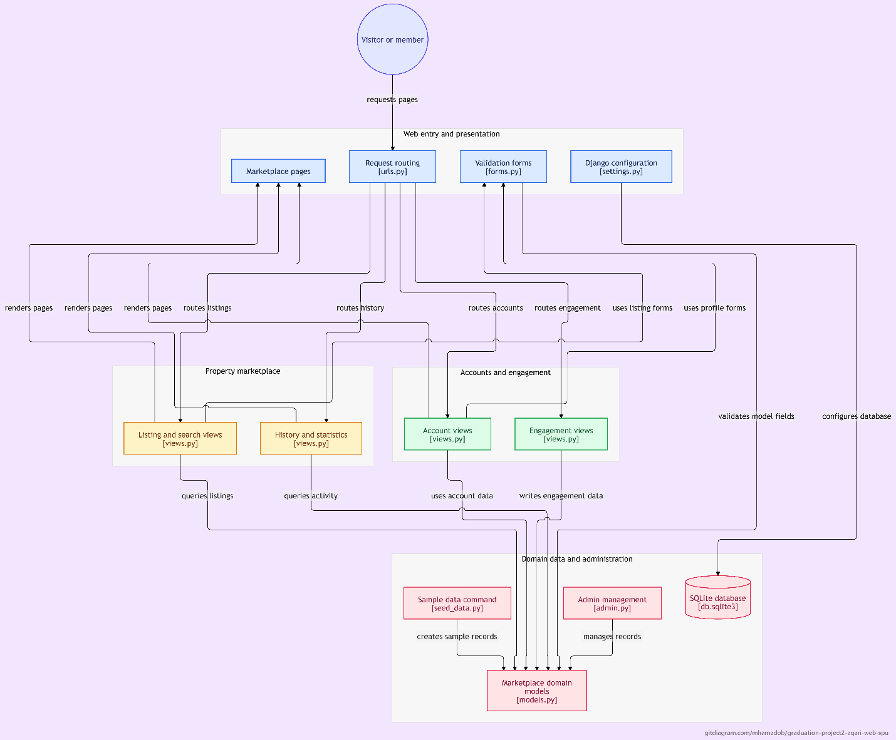
The block diagram illustrates the software architecture of the "Aqari" platform based on Django’s MVT (Model-View-Template) architectural pattern. It depicts the end-to-end request/response lifecycle from user interaction to data persistent storage and back. The system is structured into four primary layers:

1. User Interaction & Web Entry Layer
- Visitor or Member: Represents the end-user initiates requests (requests pages).
- Web Entry and Presentation: Comprises core Django routing and configuration entry points:
  - Request Routing (urls.py): Intercepts incoming HTTP requests and routes them to their corresponding view logic.
  - Form Validation (forms.py): Validates and sanitizes user input and form submissions.
  - System Settings (settings.py): Holds global system configurations and database connections.
  - Marketplace Pages: Represents the user-facing interface templates.

2. Business Logic & Processing Layer (Views)
This layer handles core application logic and is split into two functional domains:
- Property Marketplace Domain:
  - Listing and Search Views (views.py): Manages property queries (queries listings), filtering, and multi-criteria search by governorate, property type, price, and status.
  - History and Statistics Views (views.py): Tracks user activity and statistics (queries activity).
- Accounts and Engagement Domain:
  - Account Views (views.py): Handles user account management and profiles (uses account data).
  - Engagement Views (views.py): Manages user interactions such as ratings, favorites, and feedback (writes engagement data).

3. Domain Data & Administration Layer
The backend persistence and administrative layer of the system:
- Marketplace Domain Models (models.py): Defines the database schemas and relationships for properties, users, and interaction data.
- Data Management & Seeding:
  - Sample Data Command (seed_data.py): Generates representative test data for development (creates sample records).
  - Admin Management (admin.py): Configures the administrative dashboard for managing database records (manages records).
- Relational Database (db.sqlite3): An SQLite file-based database storing persistent system data, schema constraints, and model instances.

4. Routing & Presentation Pipeline
Inter-layer connectors (routes listings, routes history, routes accounts) manage data flow between entry points and business logic, while the rendering engine merges model data into templates (renders pages) to return dynamic HTML responses to the end user.

